Scientific Computing

MATH6183001

**TAYLOR SERIES**

Sequence: ordered set of numbers {T1, T2, T3, ….., Tn}.

Series: sum of a sequence up until n terms: = T1 + T2 + T3 + …+Tn.

McLaurin Series (at x = 0)

$$f\left(x\right)=f\left(0\right)+\frac{f'(0)}{1!}.x+\frac{f''(0)}{2!}.x^{2}+\frac{f'''(0)}{3!}.x^{3}+\frac{f^{(4)}(0)}{4!}.x^{4}+…$$

Ex:

Find the McLaurin series about x = 0 and write it in sigma notation.

$f\left(x\right)=\sin{x}$.

$$f\left(x\right)=\cos{x}$$

$$f\left(x\right)=e^{x}$$

$$f\left(x\right)=e^{2x}$$

$$f\left(x\right)=e^{-x^{2}}$$

$$f\left(x\right)={(1+x)}^{p}$$

Taylor Series (about x = a)

$$f\left(x\right)=f\left(a\right)+\frac{f^{'}\left(a\right)}{1!}.(x-a)+\frac{f''(a)}{2!}.({x-a)}^{2}+\frac{f'''(a)}{3!}.({x-a)}^{3}+\frac{f^{(4)}(a)}{4!}.({x-a)}^{4}+…$$

Rn = remainder = $\int_{a}^{x}{\frac{f^{(n+1)}(t)}{(n+1)!}.({x-t)}^{n+1}}dt$

Example:

Compute a Taylor Series expansion for f(x) = 5x2 + 3x + 5 around a = 0 and a = 1. Show that f(x) and the Taylor series are identical.

Ex: Approximate $\frac{1}{4.41}$ using Taylor series (3 non-zero terms), 4 d.p

In numerical analysis there are 2 type of errors:

1. round-off error

2. truncation error

Ex:

4 terms, e2 = 6.3333

5 terms, e2 = 7.0000

6 terms, e2 = 7.2667

….etc → there is truncation error.

**Estimating Truncation Errors**

$$f\left(x\right)=f_{n}\left(x\right)+E_{n}(x)$$

$f_{n}\left(x\right)=$ Taylor series n terms

$E_{n}\left(x\right)$ = truncation error

$E_{n}\left(x\right)=\frac{f^{(n+1)}(z)}{(n+1)!}.({x-a)}^{n+1}$; a < z < x.

$\left|E_{n}\left(x\right)\right|≤\frac{M}{(n+1)!}.({x-a)}^{n+1}$; M = max of $\left|f^{(n+1)}\right|$

Example:

Estimate the remainder bound for the approximation using Taylor series for e2 using n = 9 around a = 0.

**Visualization**

$f\left(x\right)=e^{x}=1+\frac{x}{1!}+\frac{x^{2}}{2!}+\frac{x^{3}}{3!}+\frac{x^{4}}{4!}+…$ at x=0.

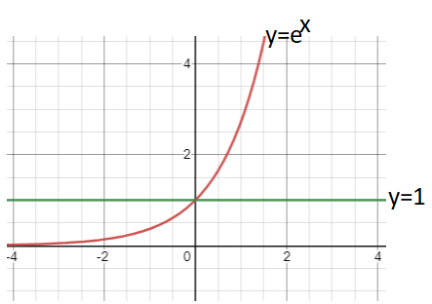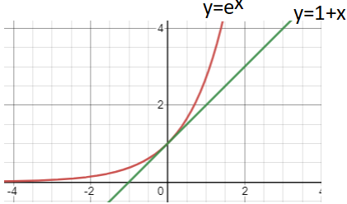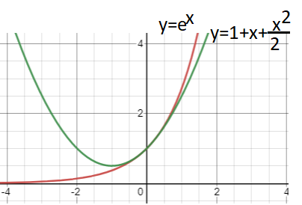

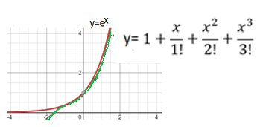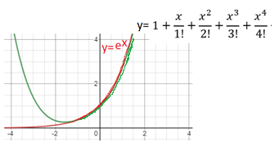

Ex:

1. Given f(x) = ln (x).

a. Estimate ln(1.1) by 4th order of Taylor series at x = 1.

b. Find the maximum error.

c. Find the actual error.

d. Compare b and c.

2. Given f(x) = $\sqrt{x}$.

a. Estimate $\sqrt{1.2}$ by 2nd order of Taylor series at x = 1.

b. Find the maximum error

c. Find the actual error.

d. Compare b and c.

3. Given f(x) = ${ \left(1-x\right)}^{\frac{1}{3}}$

a. Estimate ${ \left(0.5\right)}^{\frac{1}{3}}$ by 3rd order of Taylor series at x = 0.

b. Find the maximum error

c. Find the actual error

d. Compare b and c.